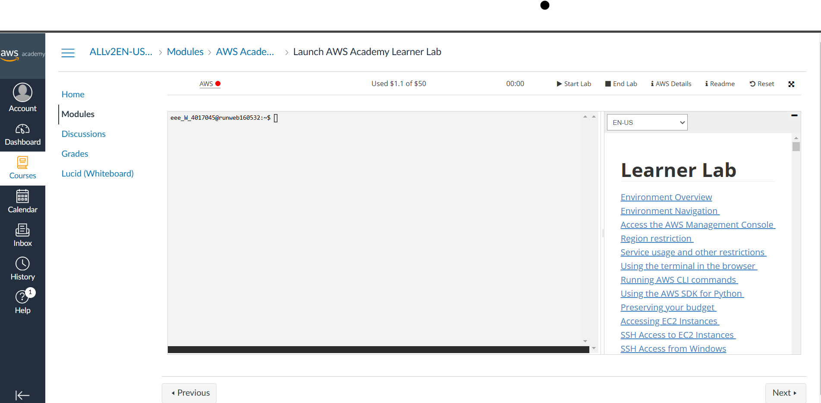
Click on AWS, and in Recently visited click on EC2

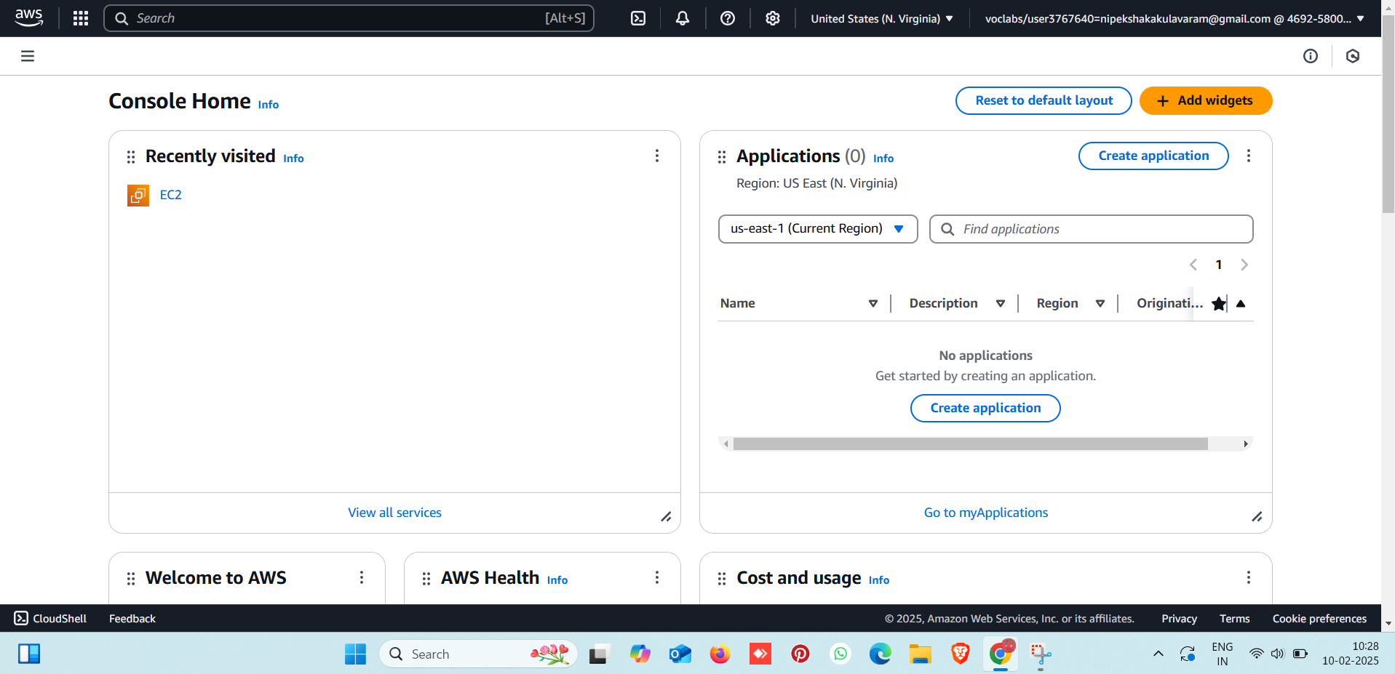

EC2 opens ,click on “Lauch Instance”:
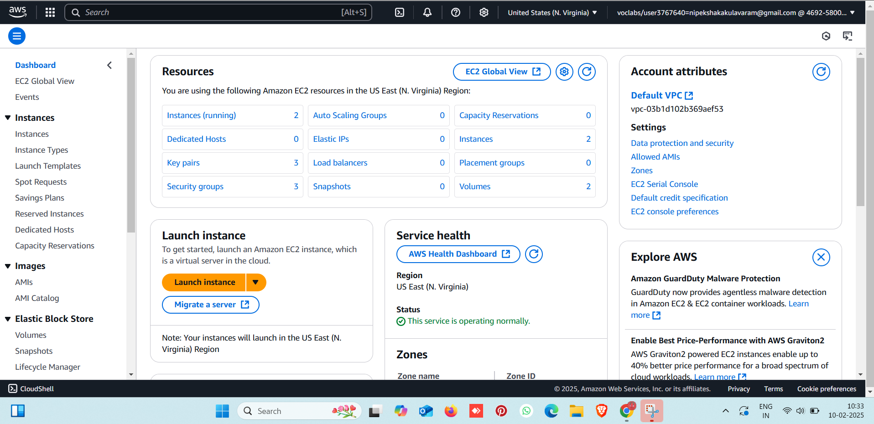

Update name and tags with your 22BD1A057A_EC2 and click on ubuntu:

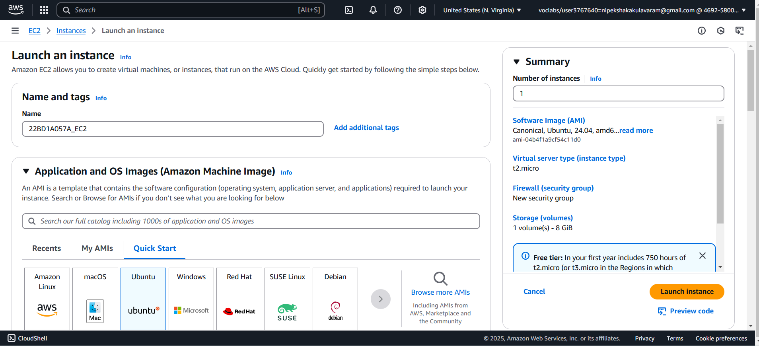

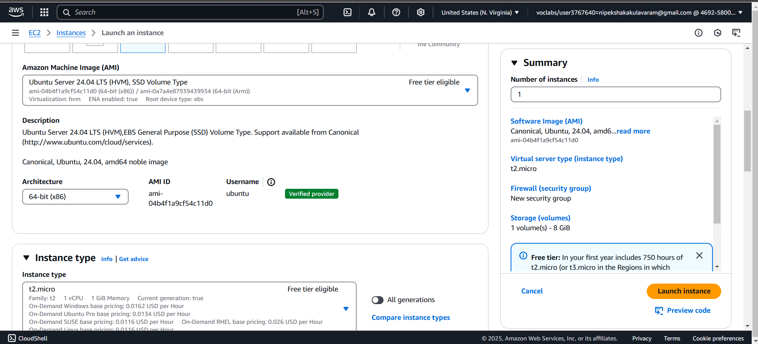
Scroll down and click on create key-pair and name it as cc_lab1 and click on create key-pair

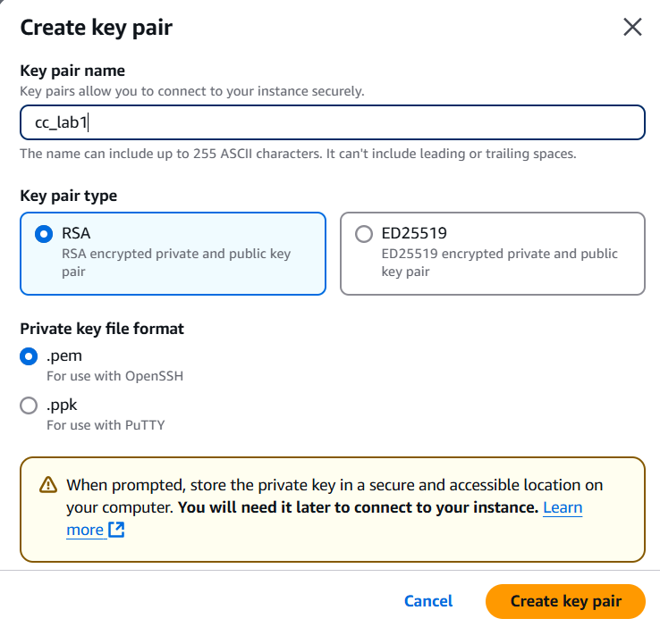

Go to network settings and check whether “allow ssh traffic” is selected or not. And click on launch instance

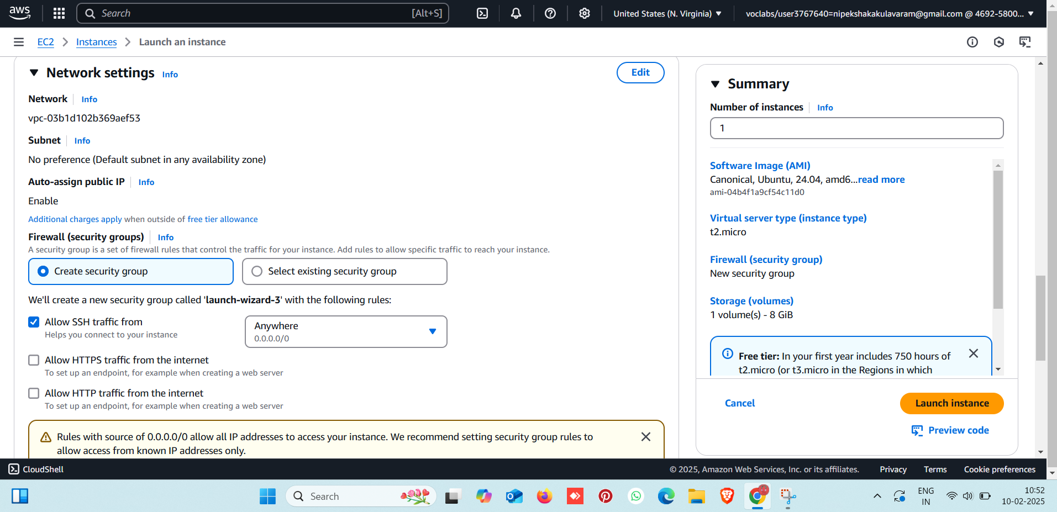

Launching instance….

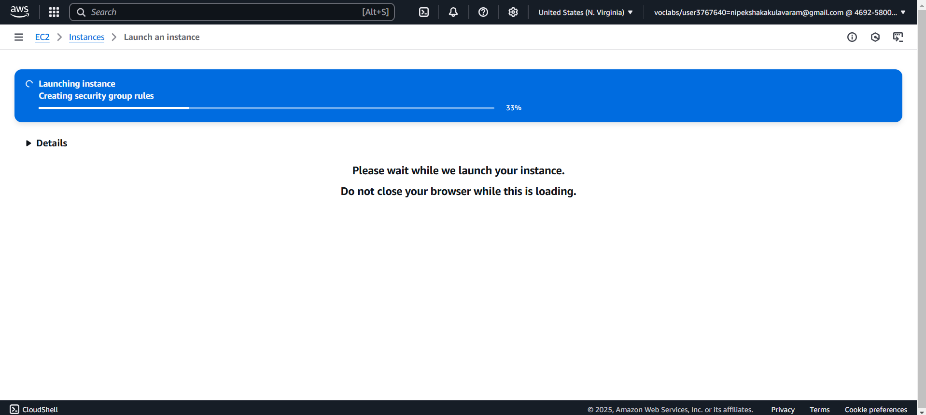
Instance has been successfully lauched

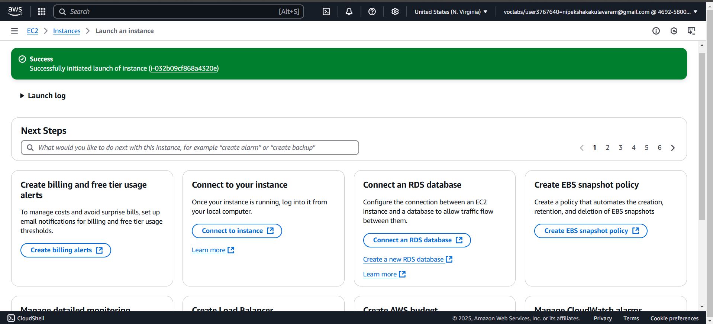
A new instance named 22BD1A057A_EC2 has been created. Select and click on connect

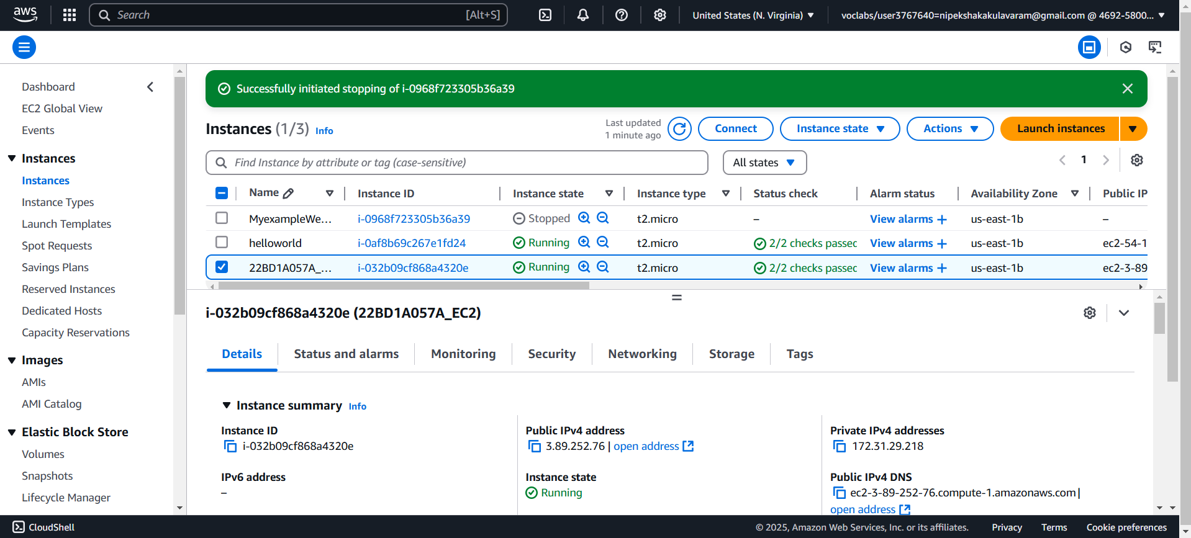
This page appears
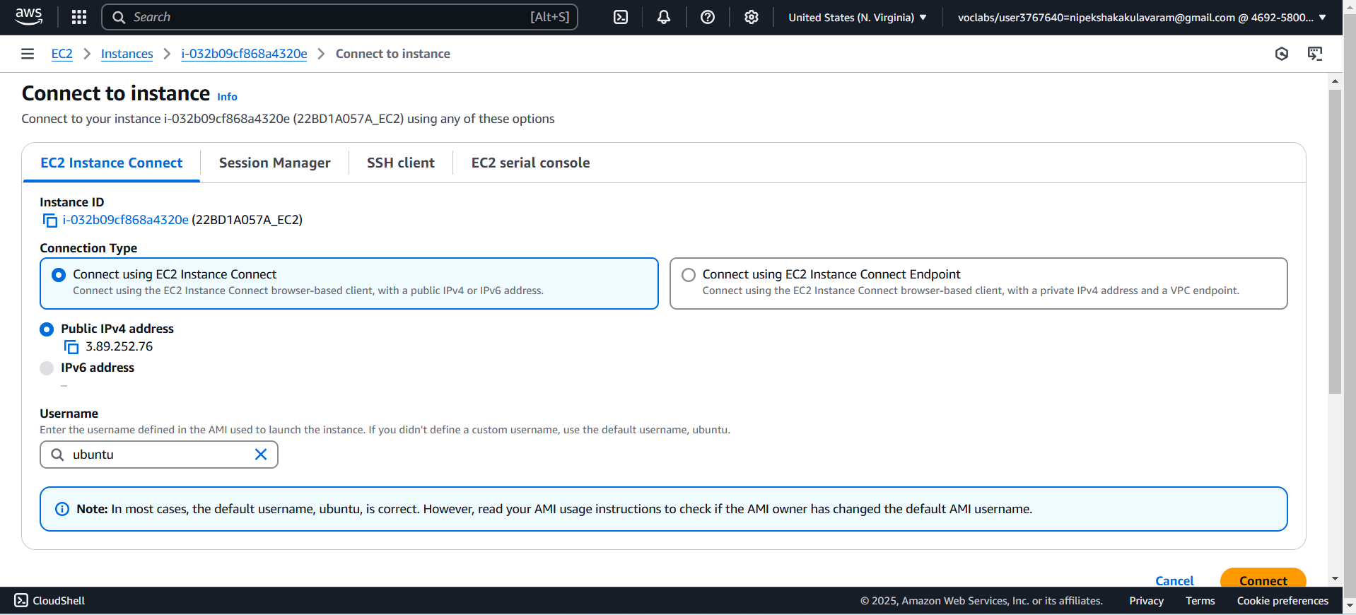
Click connect….an EC2 Instance connection gets created

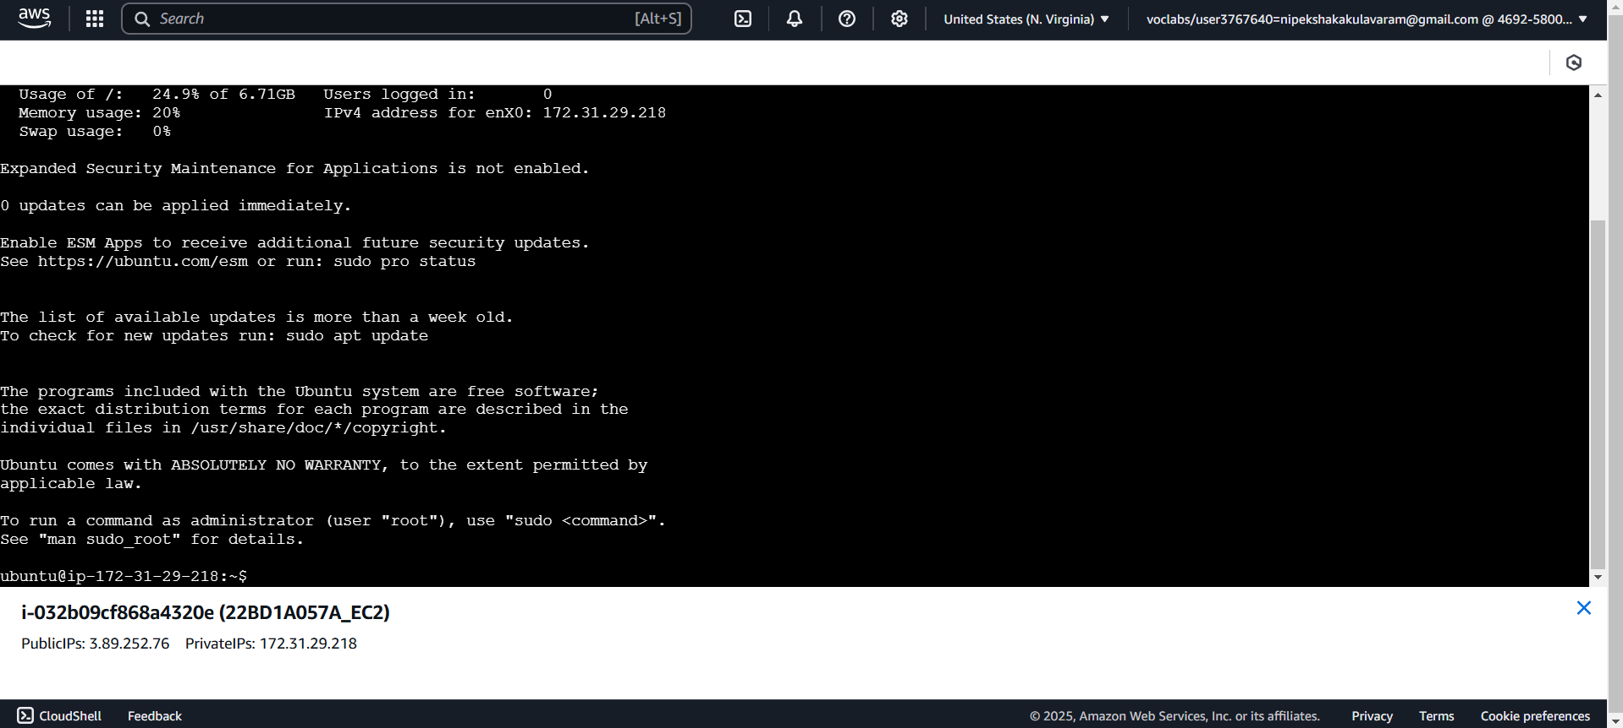
In the prompt type :java -version
sudo apt install open-jdk-21-jre-headless
(jdk version 21 gets installed)
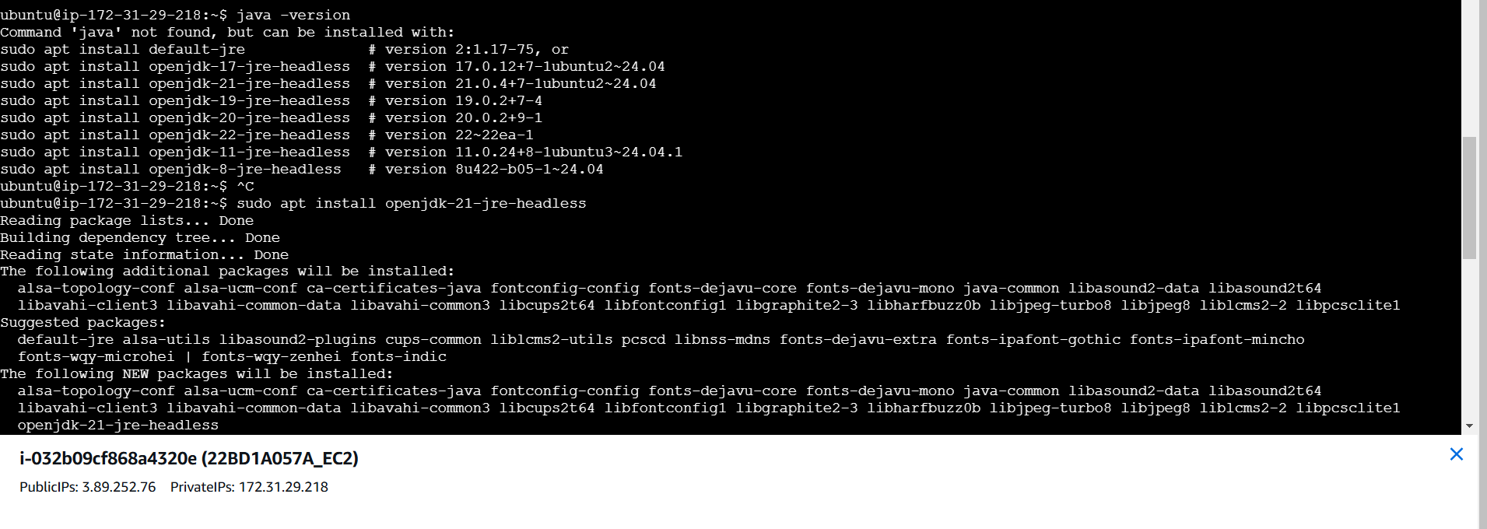
In the prompt : sudo apt-get update(updates to current version)

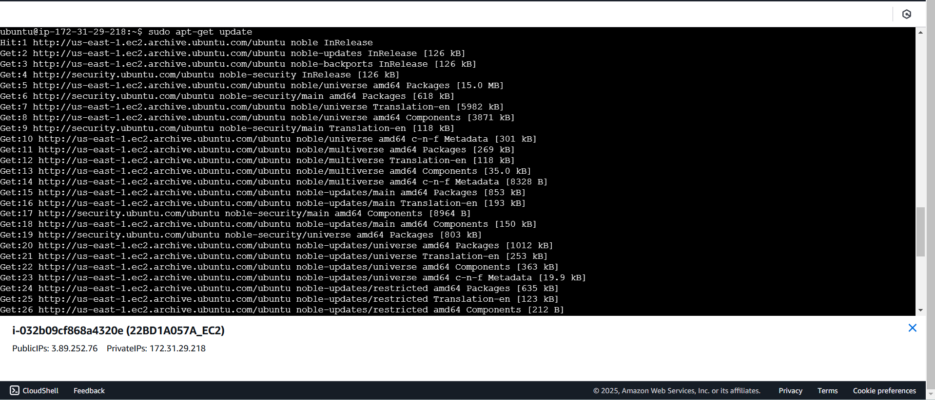
Type : vi factorial.java(changed from 22BD1A057A TO factorial)
And type “i” to insert/write the code
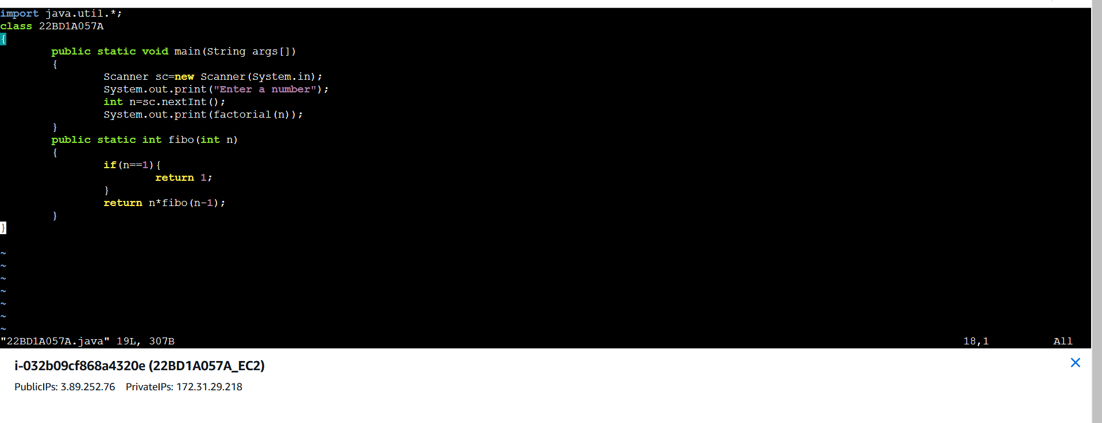
Press “:wq” to exit the vi editor and compile the code by typing:javac fatorial.java
And run the code : java factorial
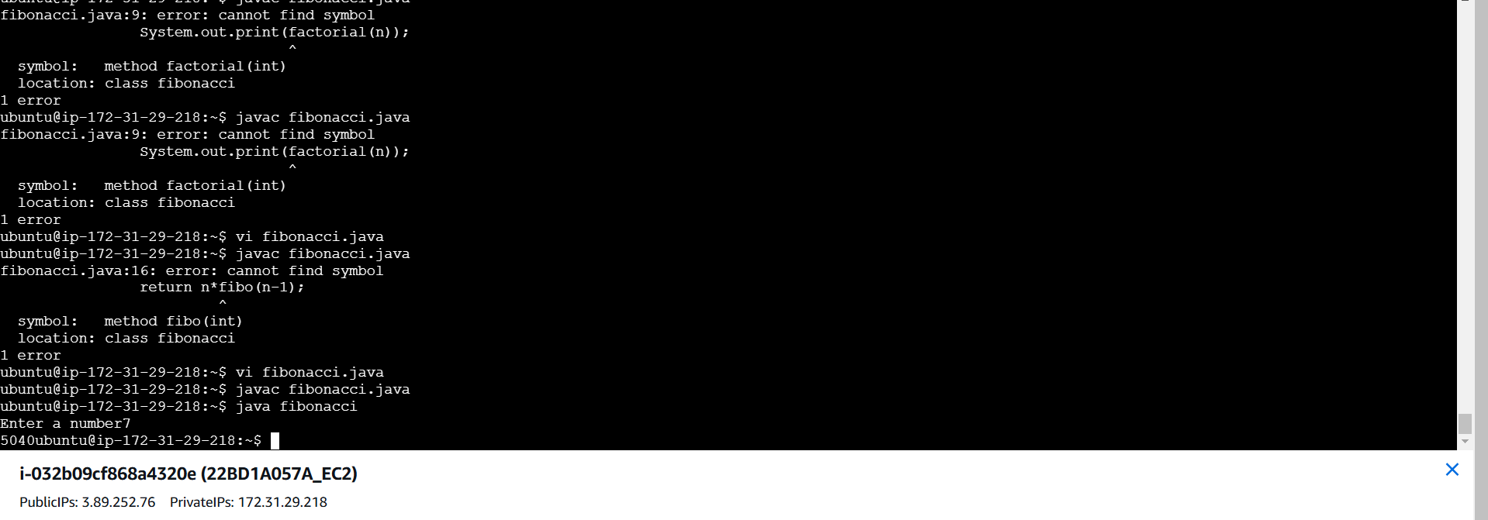

Download puTTY

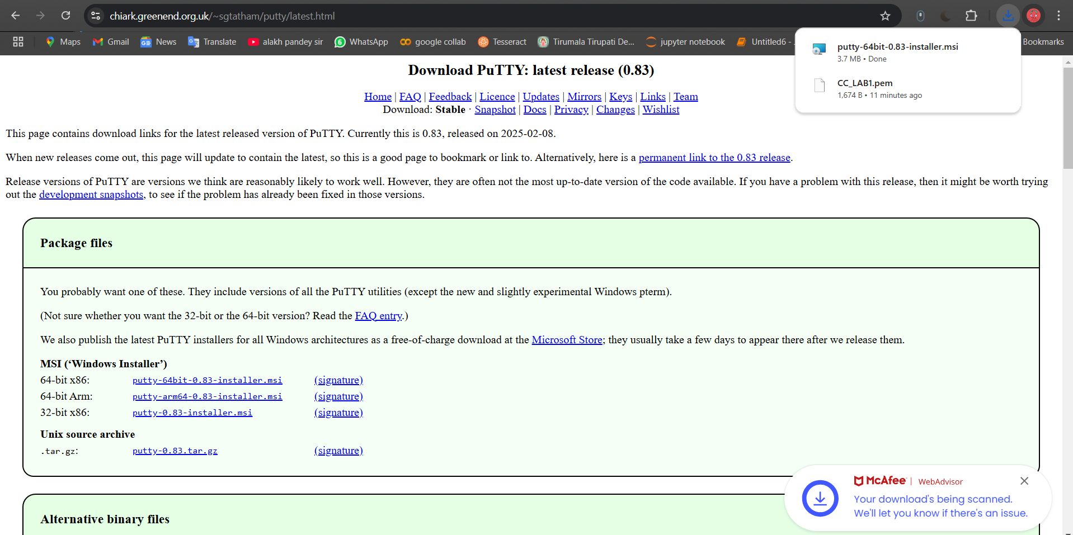
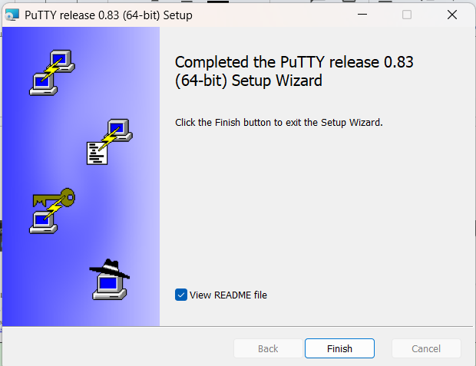
Open puTTY gen and click on load
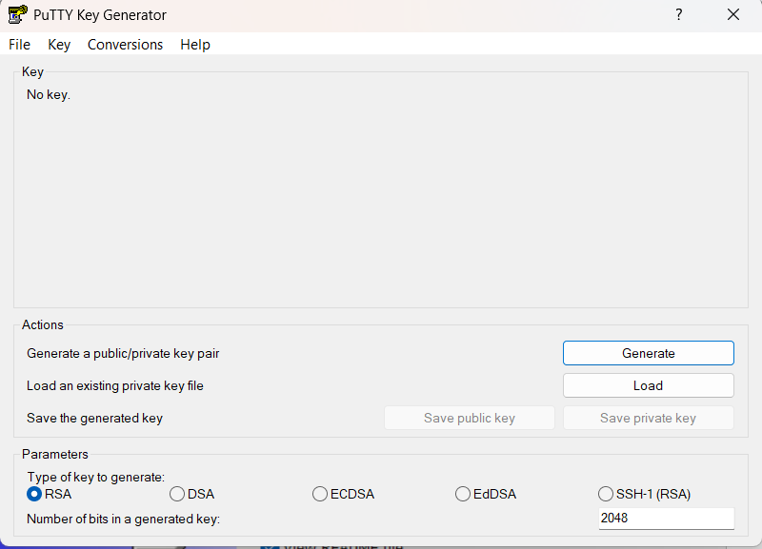
Enter the .pem file which was downloaded while creating an instance. And change the files to “all files” and click open
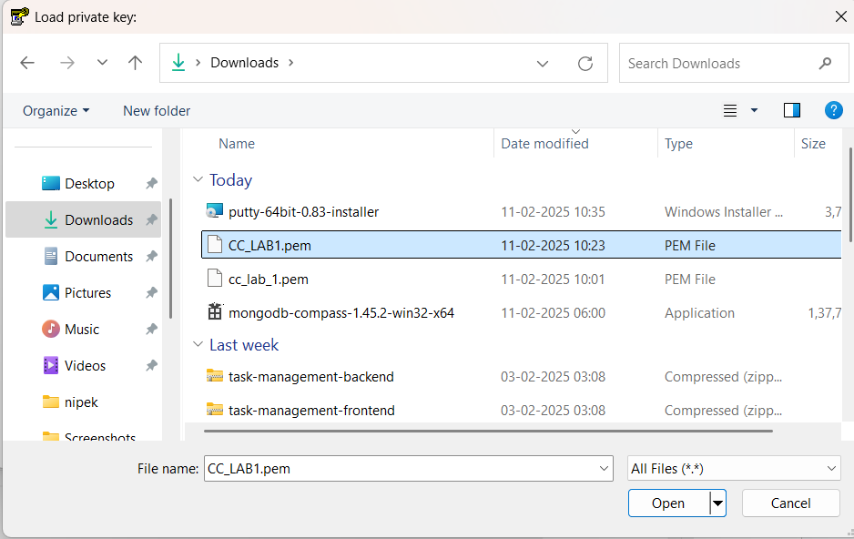
Copy the SSH key from SSH client 4th option:” Connect to your instance using its Public DNS:” and paste it in the host Name of puTTY app
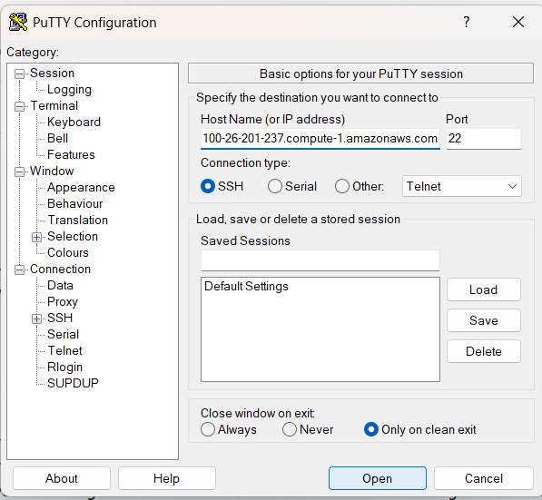
Click Connection -> Data -> Auto-login username -> ubuntu
Then
SSH->Auth->Credentials->putty_key_7a->open
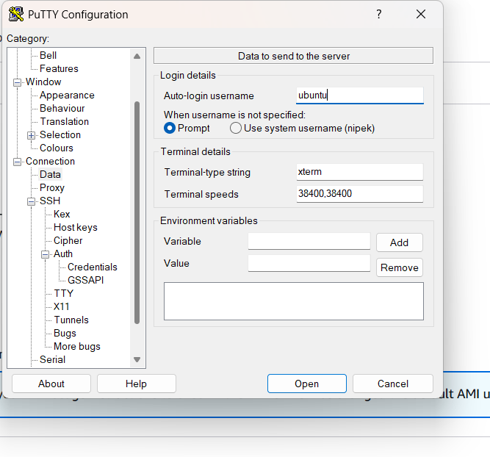
A terminal opens. Now type ls,
Factorial.class factorial.java shows up

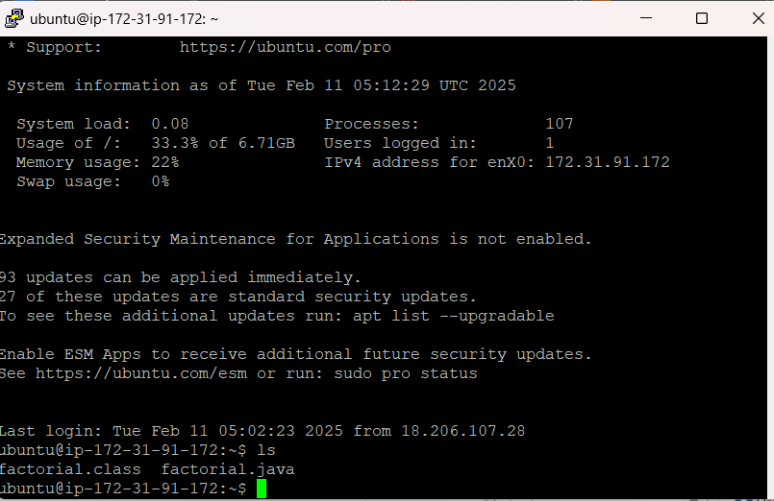
In EC2 Instance type ls->Output: Factorial.class factorial.java
